
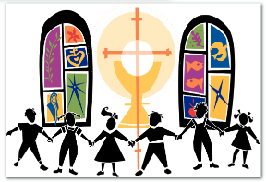
St Francis Roman Catholic Primary School
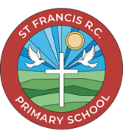

Religious Education
At St Francis RC Primary School, we follow the Religious Education Directory To Know You More Clearly to guide our teaching of RE. This directory sets out what children learn at each stage and has been carefully created and approved by the Bishops’ Conference to reflect the beliefs and values of the Catholic faith.

The Department of Education and Formation makes sure these programmes are suitable for schools, helping us provide high-quality Religious Education that supports your child’s spiritual growth and understanding of their faith.

The Religious Education Curriculum is enriched by ways of knowing and throughout the curriculum children will experience, be taught through, and learn by understanding, discerning, and responding. Children will be enabled to SEE-JUDGE-ACT.

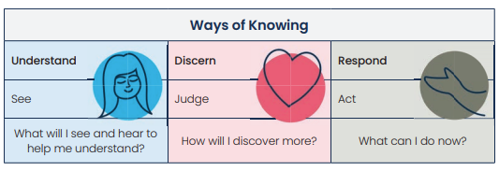
Aims of Religious Education
- To explore the mystery of God and the life of Jesus
Children are guided through a thoughtful study of God, the teachings of Jesus Christ, and the beliefs of the Catholic Church. They learn how faith connects with everyday life.

- To deepen understanding and expression of faith
Pupils are encouraged to grow in their religious knowledge and develop the confidence to talk about their beliefs in meaningful ways.

- To provide a moral and social compass
Through learning about the Church’s teachings on how we live and treat others, children gain a strong foundation for making good choices and engaging with the world around them.

- To understand and respect other beliefs
Pupils learn about different religions and worldviews, helping them to appreciate diversity and engage in respectful conversations with others.

- To think critically about faith and culture
Children are supported in developing their thinking skills so they can understand how faith relates to life, culture, and the world today.

- To inspire personal meaning and reflection
Religious Education encourages children to ask big questions, use their imagination, and seek personal meaning through the truth and beauty of the Catholic faith.

- To connect faith with other areas of learning
Pupils are helped to see how what they learn in Religious Education links with other subjects, enriching their overall understanding and development.

Intent
What are we trying to achieve for our children in Religious Education?
- Religious Education is at the heart of our curriculum. It is the foundation from which all other learning flows, shaping the values and ethos of our school community.

- RE is taught as a rigorous academic subject, with the same structure, depth, and expectations as other core subjects like English and Maths.

- Our RE curriculum is woven into a broad and balanced timetable. It supports and enriches learning across all subjects, helping children make meaningful connections between faith and everyday life.

- In every year group, RE is taught for at least 10% of the weekly timetable, ensuring children receive consistent and high-quality religious education throughout their primary years.

Implementation
How is the curriculum delivered
Our Religious Education curriculum is built around six key areas, known as "branches." These branches align with the six half-terms of the school year and help children explore their faith in a clear, engaging, and age-appropriate way.
- Each branch focuses on a central theme of the Catholic faith, such as God's message, the life of Jesus, and the teachings of the Church.

- Children learn how to live as Christians today, guided by Gospel values and the example of Christ.

- Lessons encourage pupils to think about what their faith means in everyday life and how it influences their choices and actions.

- Through reflection and discussion, children grow in spiritual understanding and develop a deeper connection to their beliefs.

- The curriculum supports children in becoming confident, compassionate, and thoughtful individuals who live out their faith with care.

- This structured approach helps pupils build a strong foundation in Catholic teaching while encouraging personal growth and moral development.

Impact
What difference is the curriculum making?
The impact of our Religious Education curriculum is seen in the way children grow in faith, understanding, and character. Through engaging lessons and meaningful reflection, pupils become religiously literate and spiritually aware, developing a strong foundation in Catholic beliefs and values.
As they progress through school, children learn to think ethically and theologically, appropriate to their age and ability. They begin to ask thoughtful questions, reflect on their choices, and understand how their faith guides everyday life. Our aim is to nurture our children about their religion and live it out with compassion, integrity, and purpose.
Religious Education helps children become confident in expressing their beliefs, respectful of others, and equipped to make a positive difference in the world around them.

